BREAKFAST CHATTER
Weekly Bulletin of Rotary Club of Kathmandu Mid-Town
District 3290 Volume No. 15/15 for #757 October 29 2004
www.rotarymidtown.org.np
OCTOBER IS VOCATIONAL SERVICE MONTH

SUNSHINE ANNOUNCEMENT FOR THE WEEK OF 29 October 2004;
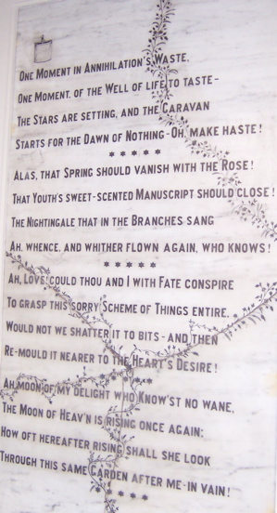
No B’s, No A’s. Instead this week you get a poem as substitute—from the Garden of Dreams
*******************

MEETING ACTIVITIES:
DATE | ACTIVITY | SUBJECT
29 OCT | Shyam Nepali | All about Sarangis (music included)
5 NOV | Biswajit Chakraborty | Topic to be Announced
****************
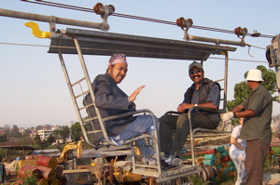
NEWS ……In early November all Rotarians and their families will be invited to ride EcoSystems’ WireBridge at the Nakhu Khola:

****************
THIS WEEK’S PRESENTATION BY SHYAM NEPALI
Born in 1972 in Kathmandu, he started his musical education of singing, dancing and playing sarangi at the age of eight with his grandfather Magar Gaine and father Ramsharan Nepali. Shyam's first public appearance was during a music competition at the Royal Nepal Academy when he was fifteen. Later he created a band Surva and released his first CD. His discography currently includes Heart Sutra Journey of Nepal, Lumbini, Sitarkhasa, and Swayambhu. He has become well-known among the young instrumentalists of Nepal. His sarangi playing reflects typical Nepalese styles, which are soft, melodic and touch the heart. He has participated in many performances in Nepal and abroad.
**************** YIR…David

